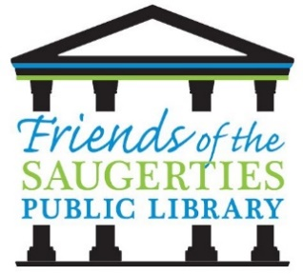 **Friends of the Saugerties Public Library**

PO Box 1100

Saugerties, New York 12477

**2025 SCHOLARSHIP APPLICATION**

**APPLICATION DEADLINE APRIL 30, 2025**

This scholarship in the amount of $1,000 will be awarded to any graduating senior (Saugerties resident) who is eligible to attend a college or university in pursuit of a higher education. The scholarship recipient will be selected based on volunteer service to the school, and/or public library, or the community, as well as a written essay. Service to libraries will be given special consideration.

Applicant’s Name: ________________________________________________________

Address: ________________________________________________________________

Telephone Number: _______________________________________________________

Parent(s)/Guardian(s): _____________________________________________________

1. To be considered for this award, please write an **essay** (typed and double spaced) explaining why you should be awarded this scholarship. List the extra-curricular activities in which you have participated as a student. Include any leadership and/or community action roles in which you have been involved. Describe your involvement in our community as a volunteer and/or event participant. Describe your activities in support of the local public library or your school library.

2. Please furnish a **transcript**.

3. Check approximate annual total family income below:

_____ Under $50,000 _____ Over $50,000

4. Number of brothers and sisters likely to be in college at the same time as applicant: ___

5. What college are you planning to attend and your intended major: __________________

________________________________________________________________________

CRITERIA: Continuing Education /Volunteer Services/Involved with School and/or Public Library

AMOUNT OF SCHOLARSHIP: $1,000.00

DEADLINE: April 30, 2025 SUBMIT: To the Senior High Office/Counseling Center